Programming – 18.11.19

* *“In the C programming language, the name of an array is the same as the address location of the 1st element in that array”*

Int my.array[s];



^  
Arrays are contigious, meaning that each memory address in an array follows after the last element in the array. This means if you know the starting hex-value (location) of that array, simply adding one to the hex will give you the next element in the array.

* EX1.c – Explanation
* EX2.c – Further Explanation

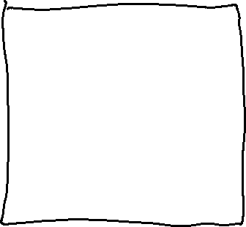

* ^ Memory view of EX2.c
* When accessing an array normally, I.E %d etc. It is called “subscript notation”.
* If accessed with pointers, it is simply called “pointer notation”.
* **arrayname[i] \*(arrayname+i)**



* So, square brackets are subscript notation. And round brackets are pointer notation.
* Scanf’s will not allow memory addresses to be scanned in.